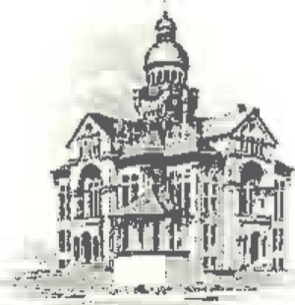PAULDING COUNTY

# COMMISSIONERS

451 McDonald Pike- Suite E ∙ Paulding, Ohio 45879

**WEDNESDAY**

**April 2, 2025**

|  |  |
| --- | --- |
| **8:00 a.m.** | **Joe Burkard (Executive Session if needed)** |
| **8:45 a.m.** | **PCED Career Day @ OSU Extension Building** |
| **10:00 A.M.** | **Scott Strahley** |