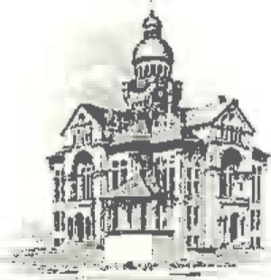PAULDING COUNTY

# COMMISSIONERS

451 McDonald Pike- Suite E ∙ Paulding, Ohio 45879

**MONDAY**

**November 11, 2024**

*CLOSED*

*Veterans Day*

**WEDNESDAY**

**November 13, 2024**

|  |  |
| --- | --- |
| **8:00 a.m.** | **Joe Burkard (Executive Session if needed)** |
| **9:30 a.m.** | **Sheriff Landers** |