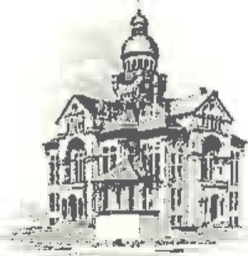PAULDING COUNTY

# COMMISSIONERS

451 McDonald Pike- Suite E ∙ Paulding, Ohio 45879

**WEDNESDAY**

**September 11, 2024**

|  |  |
| --- | --- |
| **8:00 a.m.** | **Joe Burkard (Executive Session if needed)**  **Claudia Fickel & Lou Ann Wannemacher** |
| **8:30 a.m.** | **Land Bank** |